Name : Vishal Jha

Batch : Data Engineering

Date : 12-02-2024 & 13-02-2024

Topic : Azure Databricks and Cluster (Day 1 and Day 2)

1. Created Azure Databricks Workspace:

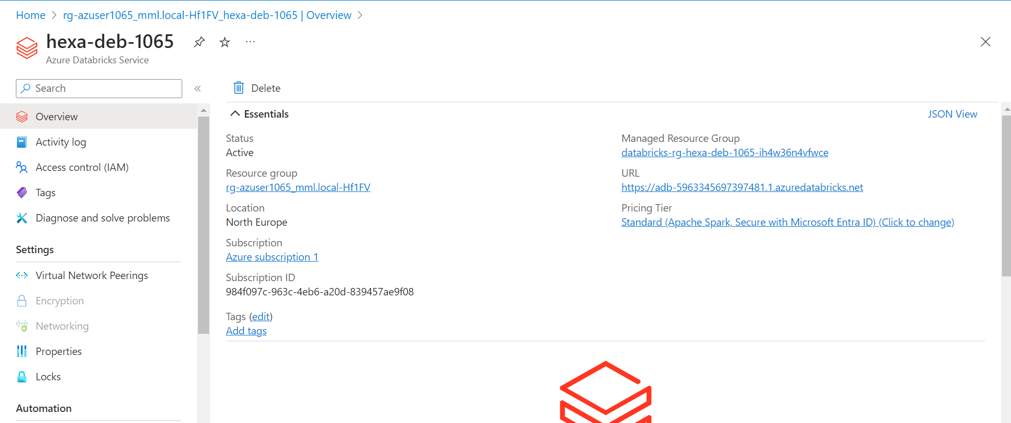

1. Compute and Created Cluster:

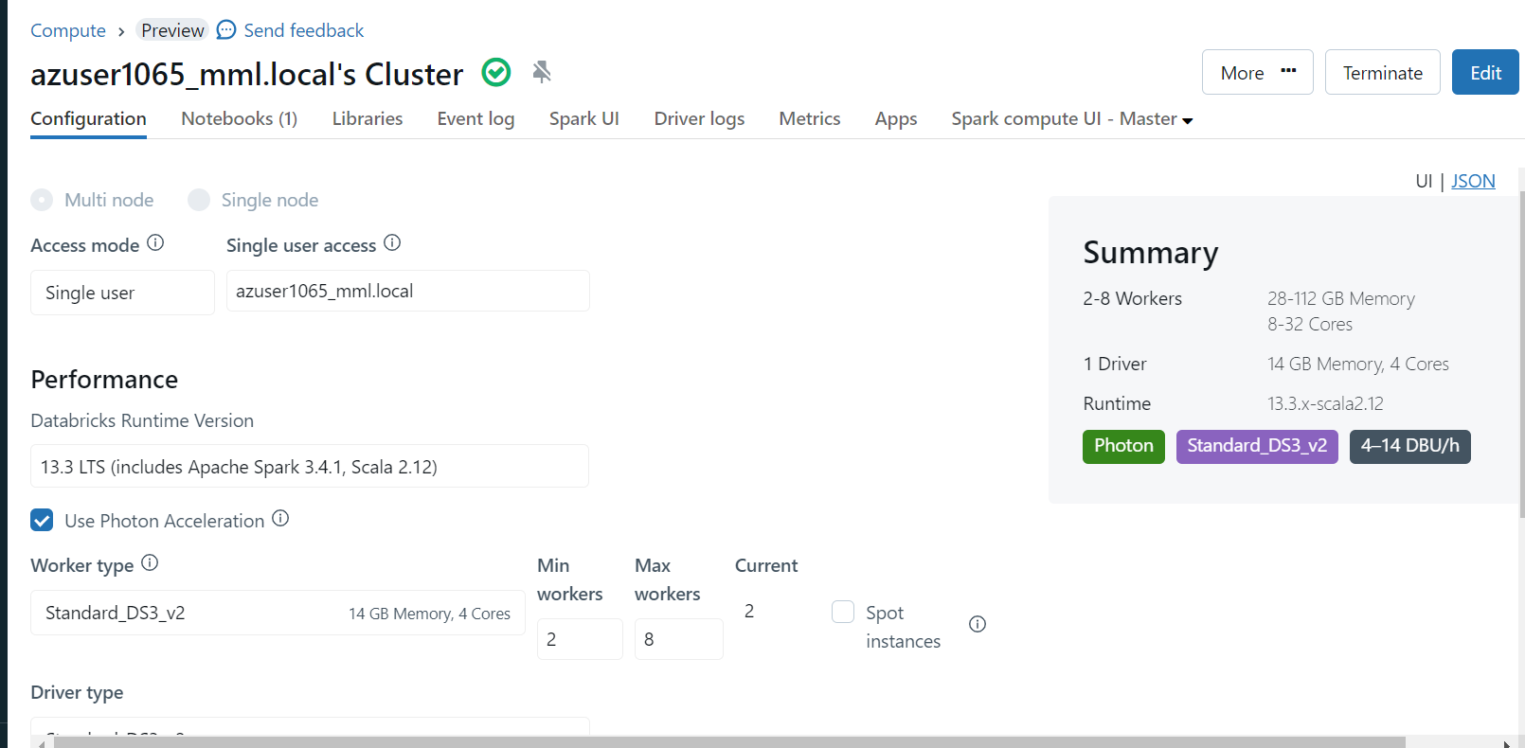

1. Run a Jupyter Notebook Code :

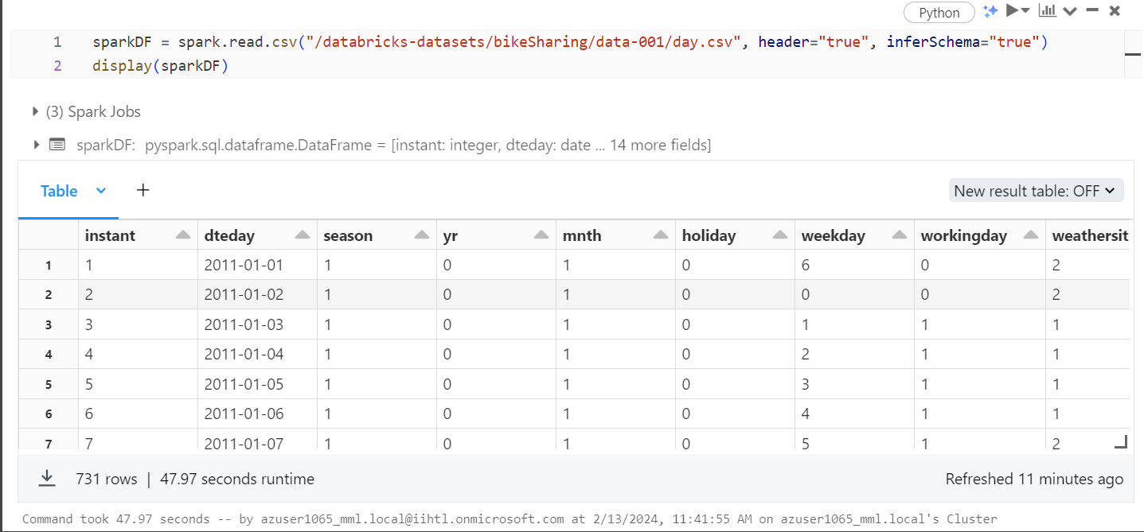

1. Created Visualization:

